Connecting with the Numinous Project
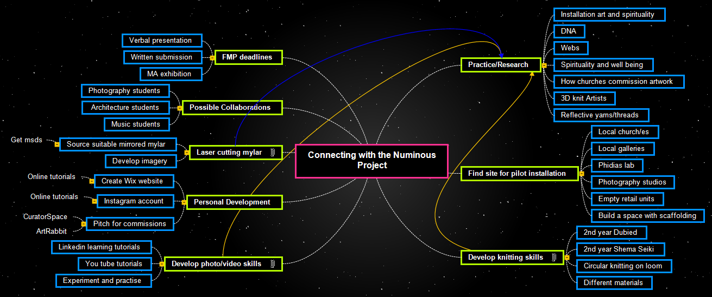
Practice/Research
Installation art and spirituality
DNA
Webs
Spirituality and well being
How churches commission artwork
3D knit Artists
Reflective yarns/threads
Find site for pilot installation
Local church/es
Local galleries
Phidias lab
Photography studios
Empty retail units
Build a space with scaffolding
Develop knitting skills
2nd year Dubied
2nd year Shema Seiki
Circular knitting on loom
Different materials
Develop photo/video skills
Linkedin learning tutorials
You tube tutorials
Experiment and practise
Personal Development
Create Wix website
Online tutorials
Instagram account
Online tutorials
Pitch for commissions
CuratorSpace
ArtRabbit
Laser cutting mylar
Source suitable mirrored mylar
Get msds
Develop imagery
Possible Collaborations
Photography students
Architecture students
Music students
FMP deadlines
Verbal presentation
Written submission
MA exhibition

Practice/Research

Installation art and spirituality

DNA

Webs

Spirituality and well being

How churches commission artwork

3D knit Artists

Reflective yarns/threads

Find site for pilot installation

Local church/es

Local galleries

Phidias lab

Photography studios

Empty retail units

Build a space with scaffolding

Develop knitting skills
See Practice/Research

2nd year Dubied

2nd year Shema Seiki

Circular knitting on loom

Different materials

Develop photo/video skills
See Practice/Research

Linkedin learning tutorials

You tube tutorials

Experiment and practise

Personal Development

Create Wix website

Online tutorials

Instagram account

Online tutorials

Pitch for commissions

CuratorSpace

ArtRabbit

Laser cutting mylar
See Practice/Research

Source suitable mirrored mylar

Get msds

Develop imagery

Possible Collaborations

Photography students

Architecture students

Music students

FMP deadlines

Verbal presentation

Written submission

MA exhibition

